 | Massachusetts Department of Environmental Protection  Bureau of Resource Protection - Wetlands  WPA Form 8A – Request for Certificate of Compliance  Massachusetts Wetlands Protection Act M.G.L. c. 131, §40 |  |  |  | DEP File Number:  197-0645  Provided by DEP
 | A. Project Information
Important: When filling out forms on the computer, use only the tab key to move your cursor - do not use the return key.  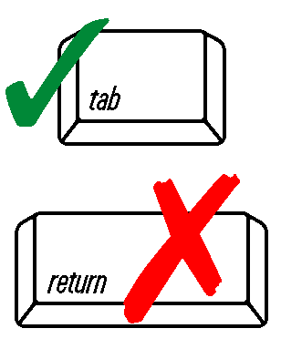 | 1. This request is being made by:
STEVEN BRIGHAM
Name
6 VALLEY FORGE CIRCLE
Mailing Address
 | WEST BOYLSTON  City/Town |  |  | MA  State | 01583  Zip Code
508-579-7227
Phone Number
 | 2. This request is in reference to work regulated by a final Order of Conditions issued to:
STEVEN BRIGHAM
Applicant
 | 4-11-2019  Dated |  |  | 197-0645  DEP File Number
Upon completion of the work authorized in  an Order of Conditions, the property owner must request a Certificate of Compliance  from the issuing authority stating that the work or portion of the work has been satisfactorily completed. | 3. The project site is located at:
 | FELIX STREET LOT A-19  Street Address |  |  | LEICESTER  City/Town
 | 19  Assessors Map/Plat Number |  |  | A 19  Parcel/Lot Number
 | 4. The final Order of Conditions was recorded at the Registry of Deeds for:
STEVEN BRIGHAM
Property Owner (if different)
 | WORCESTER - SOUTH  County |  | 60395  Book |  | 243  Page
 | Certificate (if registered land)
 | 5. This request is for certification that (check one):
 | the work regulated by the above-referenced Order of Conditions has been satisfactorily completed.
 | the following portions of the work regulated by the above-referenced Order of Conditions have been satisfactorily completed (use additional paper if necessary).
 | the above-referenced Order of Conditions has lapsed and is therefore no longer valid, and the work regulated by it was never started.
 | A. Project Information (cont.)
 | 6. Did the Order of Conditions for this project, or the portion of the project subject to this request, contain an approval of any plans stamped by a registered professional engineer, architect, landscape architect, or land surveyor?
 | Yes | If yes, attach a written statement by such a professional certifying substantial compliance with the plans and describing what deviation, if any, exists from the plans approved in the Order.
 | No
 | B. Submittal Requirements
 | Requests for Certificates of Compliance should be directed to the issuing authority that issued the final Order of Conditions (OOC). If the project received an OOC from the Conservation Commission, submit this request to that Commission. If the project was issued a Superseding Order of Conditions or was the subject of an Adjudicatory Hearing Final Decision, submit this request to the appropriate DEP Regional Office (see http://www.mass.gov/eea/agencies/massdep/about/contacts/find-the-massdep-regional-office-for-your-city-or-town.html).

